User Manual of Reports

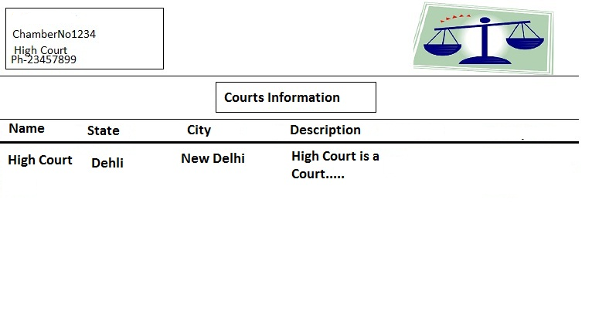

This is an example of reports generated via crystal reports. Above is the generated report for Courts Information. User can save it as pdf or print it.